Library Name: | cgm
Cell Name: | MUX2XI
Function/Truth Table:
S A B |  | Y
0 0 0 |  | 0
0 0 1 |  | 0
0 1 0 |  | 1
0 1 1 |  | 1
1 0 0 |  | 0
1 0 1 |  | 1
1 1 0 |  | 0
1 1 1 |  | 1
Propagation Delay (path based): with extracted parasitics
Transition |  | Delay (s)
A → Y ↑ (T_PLH) |  | 959.7p
A → Y ↓ (T_PHL) |  | 1.127n
B → Y ↑ (T_PLH) |  | 961.2P
B → Y ↓ (T_PHL) |  | 1.126n
S → Y ↑ (T_PLH) |  | 998.4p
S → Y ↓ (T_PHL) |  | 1.163n
Output Rise Time (path based):
Transition |  | Rise Time (s)
A → Y ↑ |  | 2.297n
B → Y ↑ |  | 2.309n
S → Y ↑ |  | 2.277n
Output Fall Time (path based):
Transition |  | Fall Time (s)
A → Y ↓ |  | 2.841n
B → Y ↓ |  | 2.849n
S → Y ↓ |  | 2.84n
Layout Height: 1.71µm
Layout Width: 1.6µm
Layout Area: 2.726µm²
Symbol with Port Names:

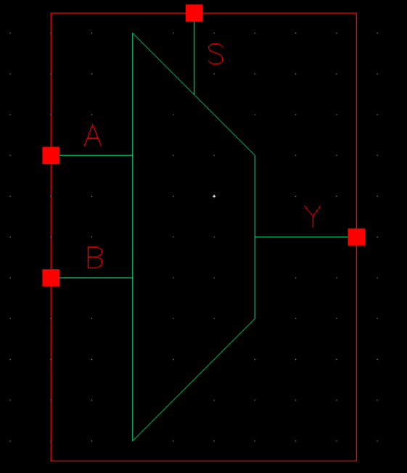
Schematic:

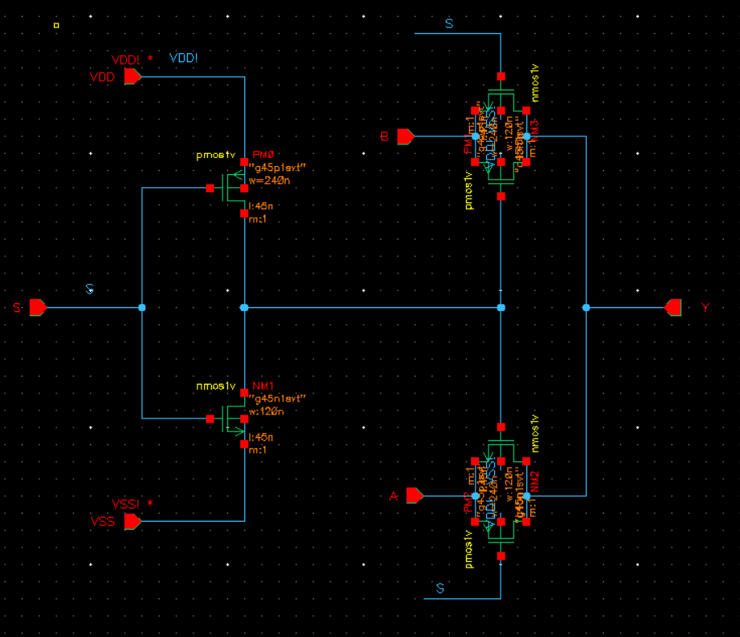
Layout:

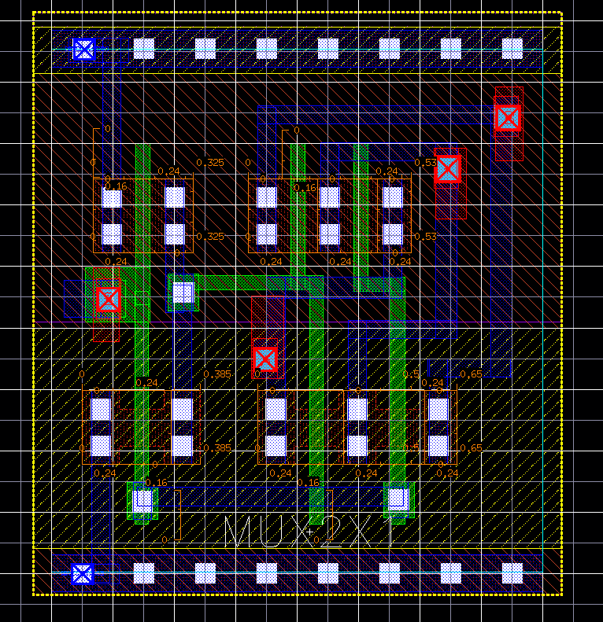
Functional Simulation Waveforms

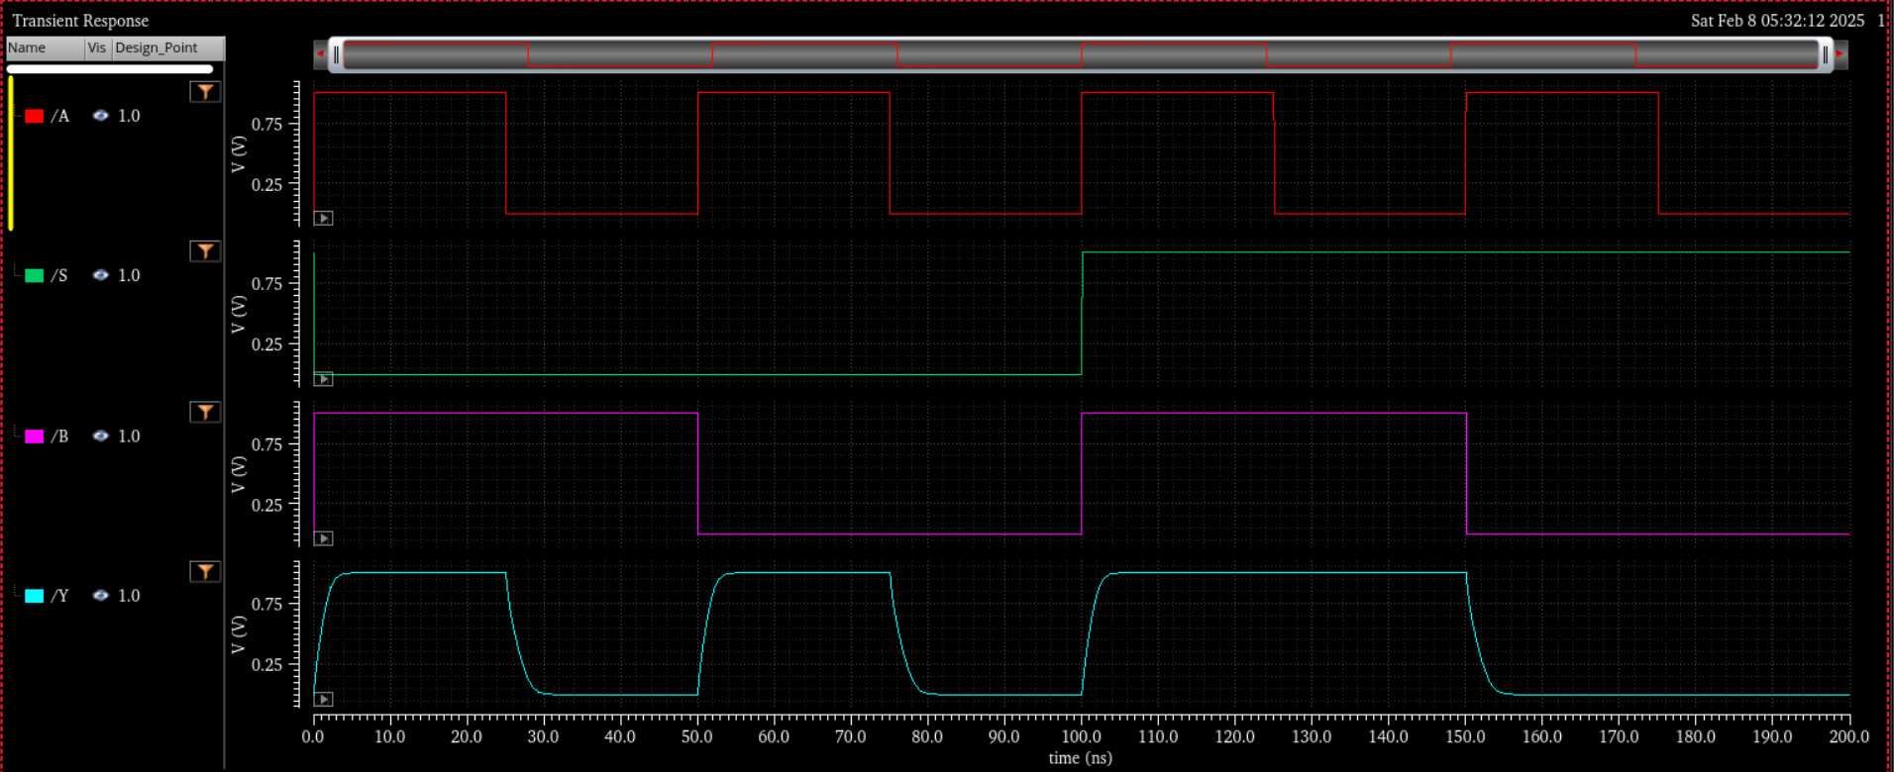

Comments/Notes:

The MUX2XI gate was tested and verified. Y follows A when S = 0 and B when S = 1, confirming correct functionality. Propagation delays and rise/fall times were within expected ranges, with fall transitions being slightly longer. All functional and timing tests passed, ensuring reliable operation.

